**Lab #2**

**Exersice: 1**

class Exercise1

{

public static void main(String args[])

{

String line1=" My name is Muskan ";

String line2=" I am from Mithi, Tharparkar ";

System.out.println(line1+line2);

}

}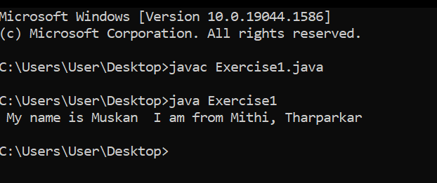

**Exercise: 2**

class Exercise2

{

public static void main(String args[])

{

String line="Muskan Maheshwari";

System.out.print(line.charAt(0));

for(int i=0; i<line.length(); i++)

{

if(line.charAt(i)==' ')

System.out.print(" "+line.charAt(i+1)+" ");

}

}

}

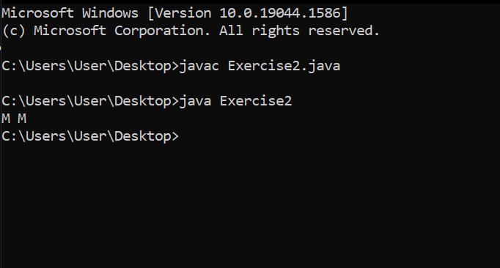

**Exercise: 3**

class Exercise3

{

public static void main(String args[])

{

String line="The quick brown fox jumps over the lazy dog.";

line=line.replaceAll("fox","cat");

System.out.print(line);

}

}

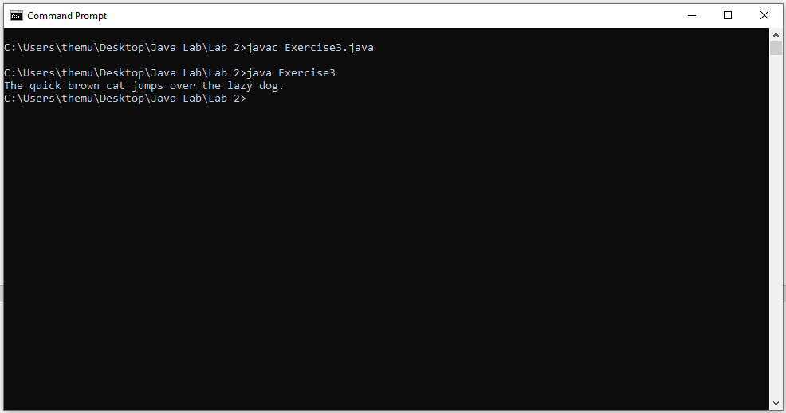

**Exercise: 4**

class Exercise4

{

public static void main(String args[])

{

int num=0;

String prime_numbers="";

for(int i=1; i<=600; i++)

{

int counter=0;

for(num=i; num>=1; num--)

{

if(i%num==0)

{

counter++;

}

}

if(counter==2)

{

prime_numbers =prime_numbers + i + "\t";

}

}

System.out.print(prime_numbers+" ");

}

}

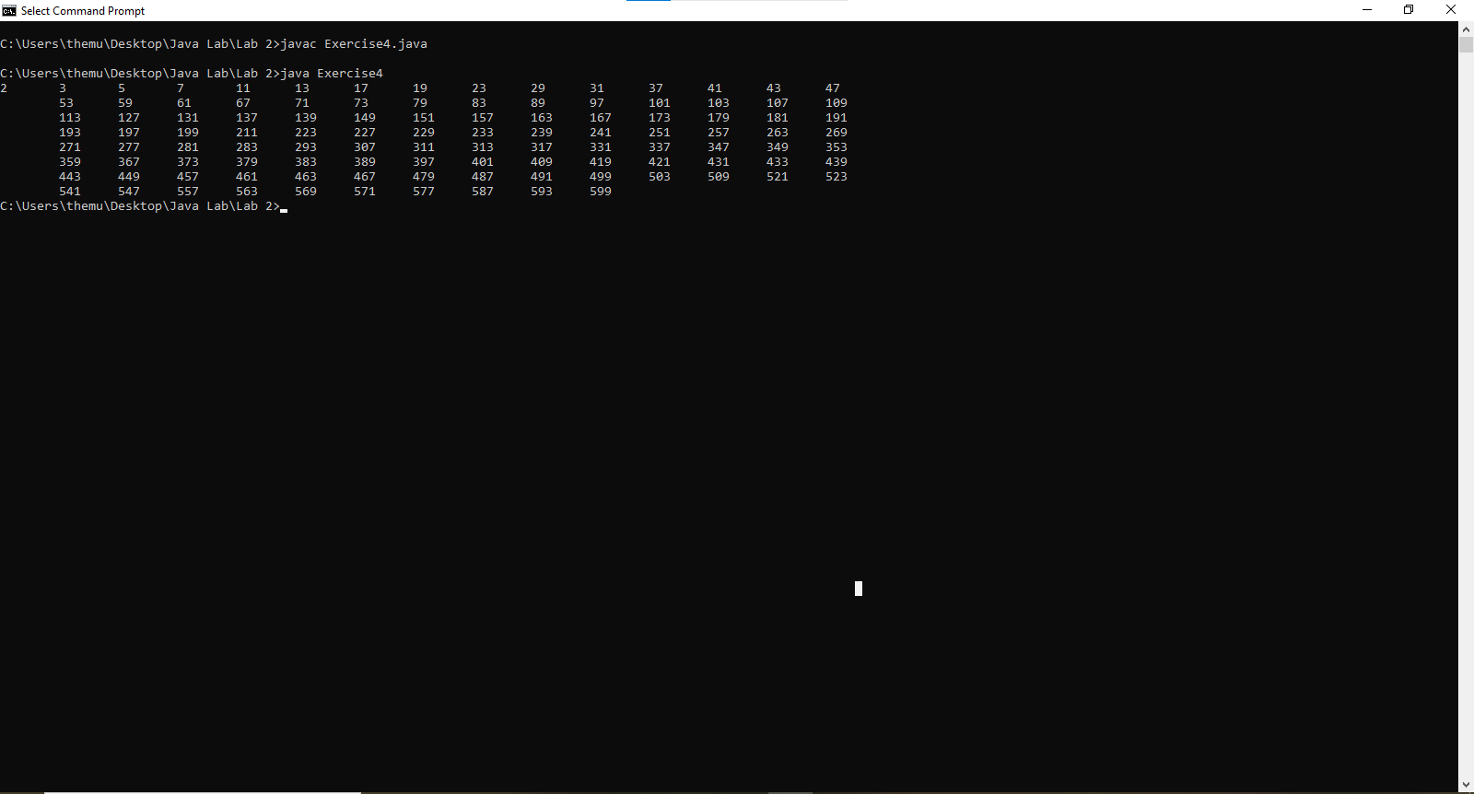

**Exercise: 5**

import java.util.Scanner;

class Exercise5

{

public static void main(String args[])

{

Scanner sc=new Scanner(System.in);

double a;

double b;

double c;

double ans1;

double ans2;

System.out.println("Enter values to apply quadratic Formulae");

System.out.print("Enter value a: ");

a =sc.nextDouble();

System.out.print("Enter value b: ");

b =sc.nextDouble();

System.out.print("Enter value c: ");

c =sc.nextDouble();

ans1=(Math.pow(((b*b)-4.0*a*c),0.5)-b)/2.0*a;

System.out.println(ans1);

ans2=(-(Math.pow(((b*b)-4.0*a*c),0.5)-b))/2.0*a;

System.out.println(ans2);

}

}

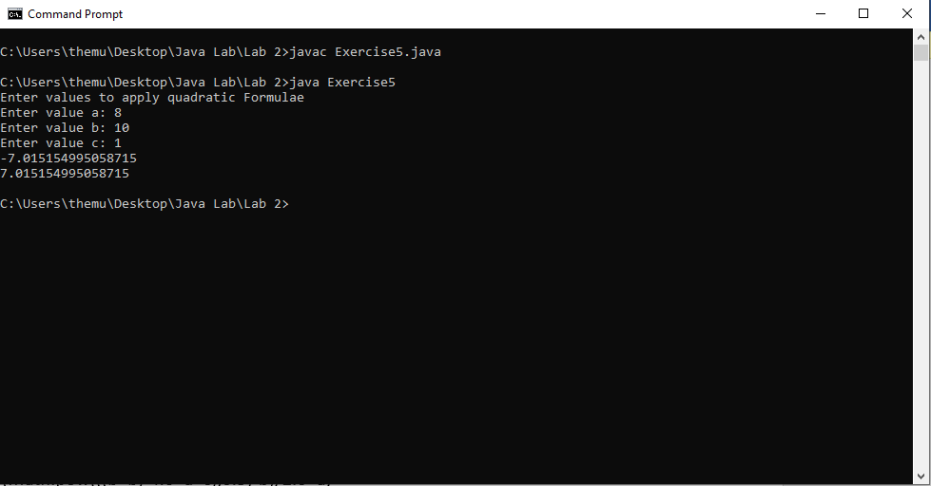

**Exercise: 6**

class Exercise6

{

public static void main (String[] args)

{

int odds[]=new int[15];

int k=0;

for(int i=1; i<=30; i++)

{

if(i % 2 != 0)

{

odds[k]=i;

k++;

}

}

for(int i=0; i<15; i++)

{

System.out.println(odds[i]);

}

}

}

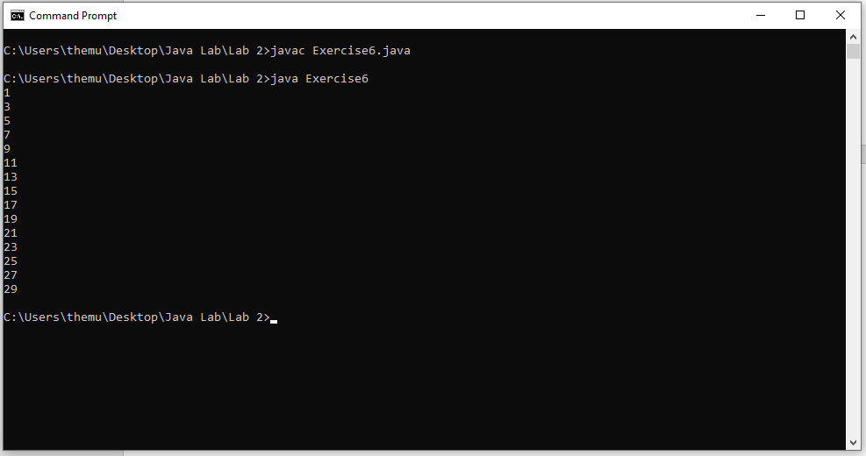

**Exercise: 7**

import java.util.Scanner;

class Exercise7

{

public static void main(String args[])

{

Scanner sc=new Scanner(System.in);

double a,b,temp;

a=sc.nextDouble();

System.out.println("First value: "+a);

b=sc.nextDouble();

System.out.println("Second value: "+b);

temp=a/b;

System.out.println("Final value: "+Math.round(temp));

}

}

